CHOY MING SAN

CHAN PAK LAM

Our website topic is about the football club. The name of the club is Borussia Dortmund. Now, I would like to introduce our website to you.

**Main**

It is the main page of the website and we made a function. When the user click Home/ Team/ History/ About/ Contact. It will bring the user to the corresponding page and highlight the current page button with a black background and yellow text. About the background of all pages, we use the football team since it is most representative.

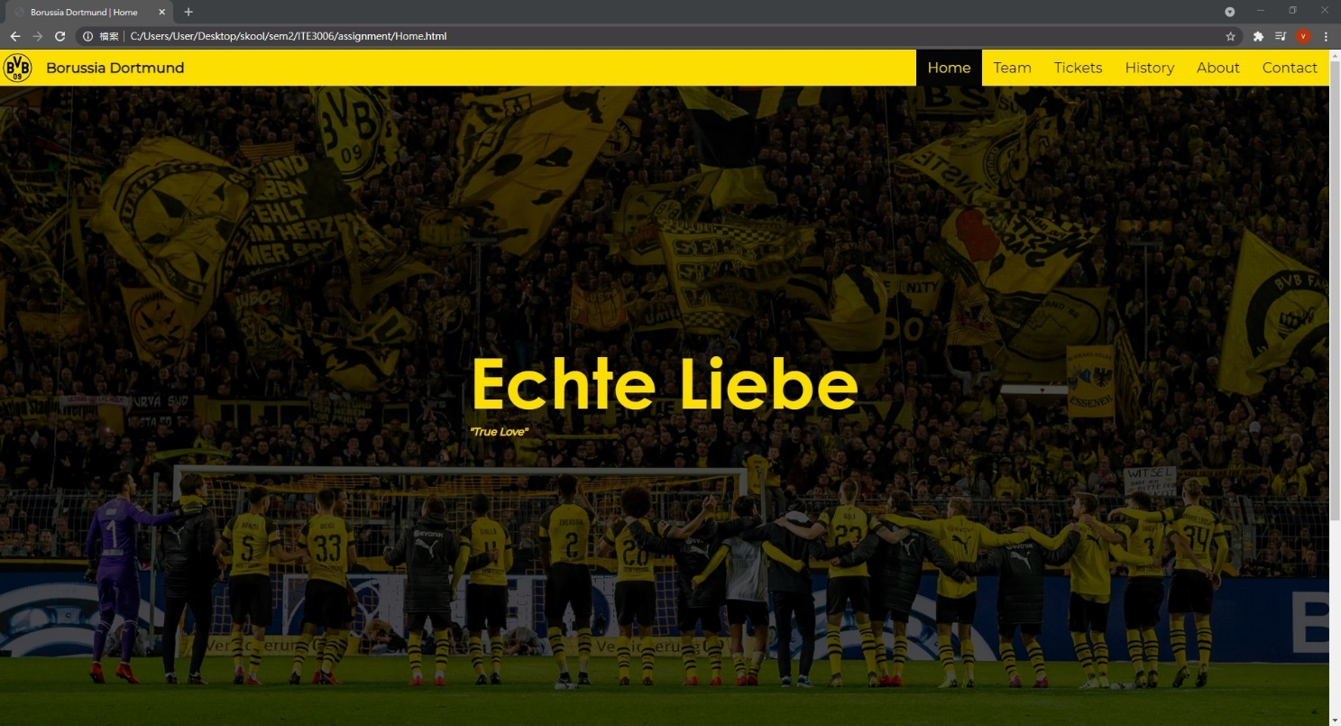

Also, when users put hover their mouse to the button. The background

color will be changed to black and text color will be changed to yellow.

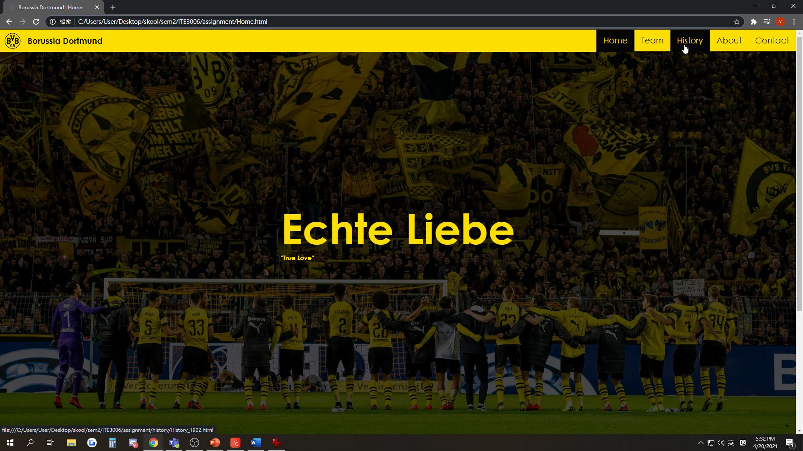

Responsive Layout:

The team logo in the navigation bar will be centered when the window gets narrow.

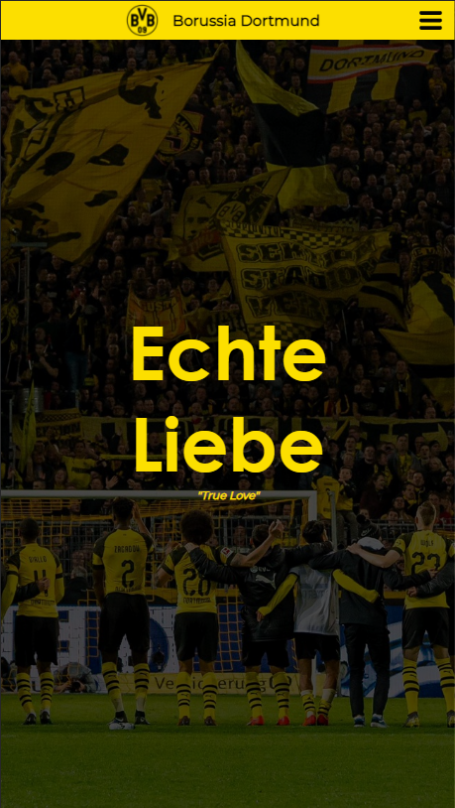

**Team**

On the ‘Team’ page, the user can see the football team members on this page. When they want to know more information about the team member they watching. They can put their mouse on the picture. It will show an underline and the user can click the picture to the page that introduces the team member (user will leave our website to another website).

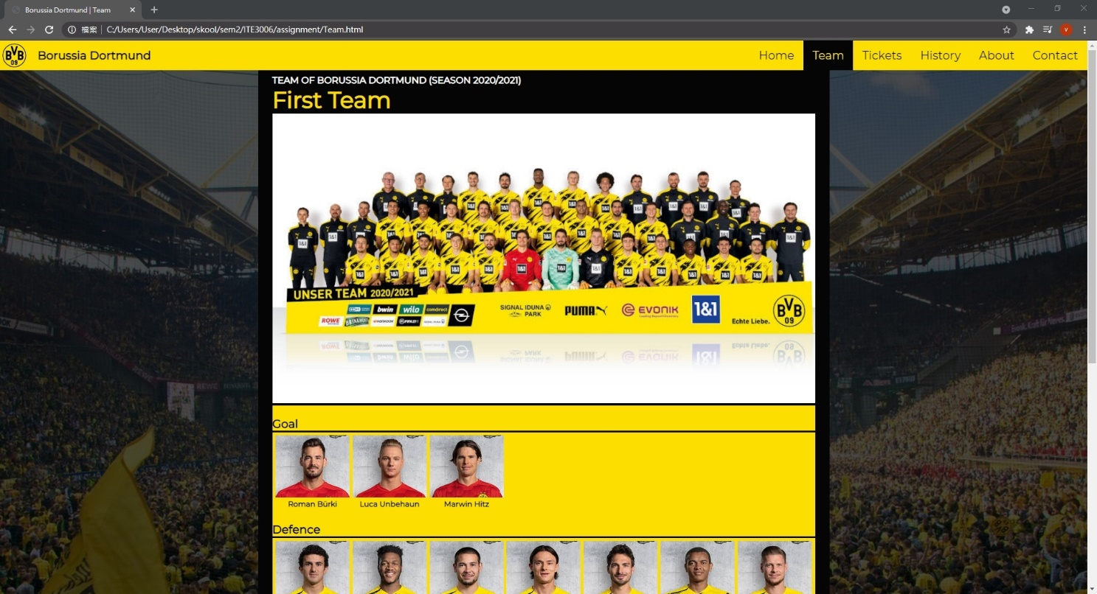

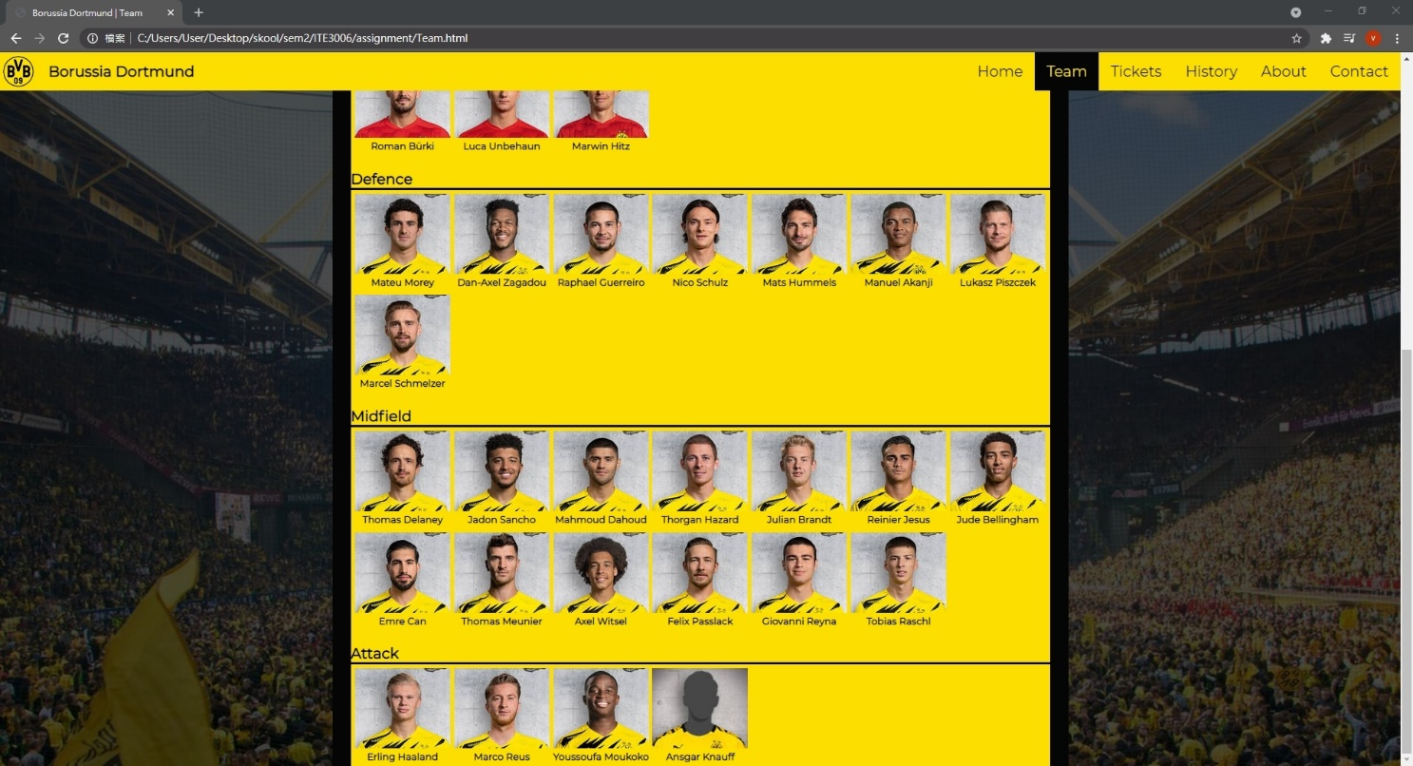

Hover effect:

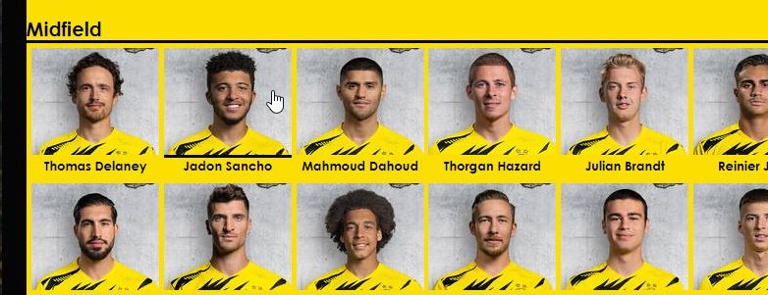

External website when the user clicked on a player icon showing the player’s detailed information:

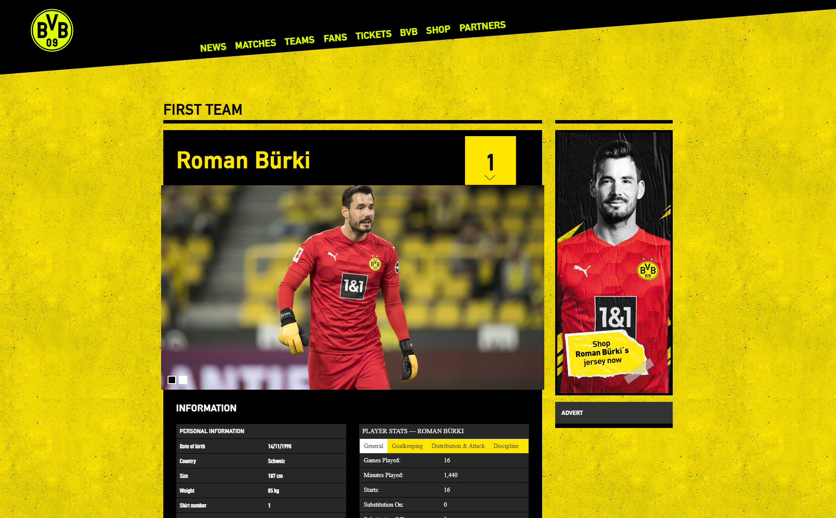

Responsive Layout:

The team photo will be hidden and the player icons will be wrapped when the window gets narrow.

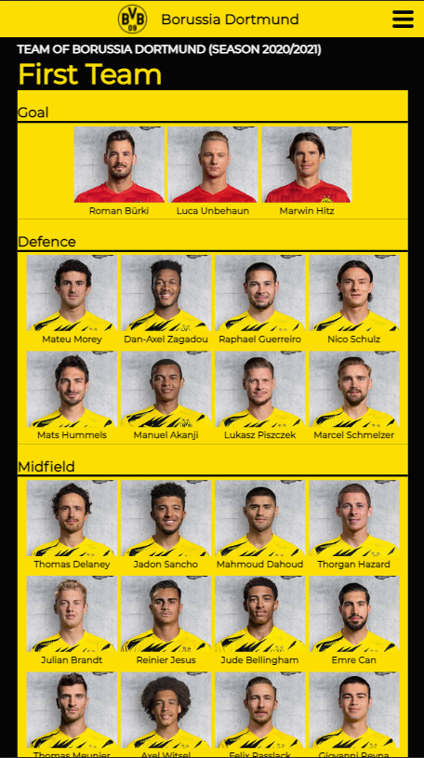

**Tickets**

A form for buying tickets.

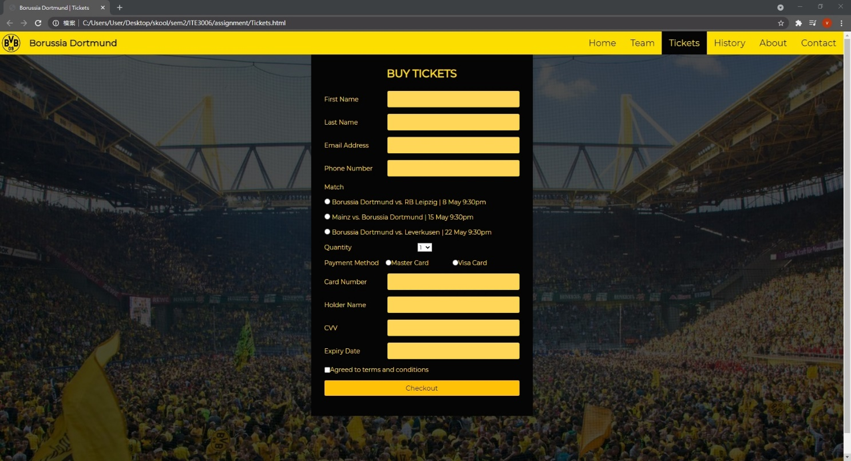

Responsive Layout:

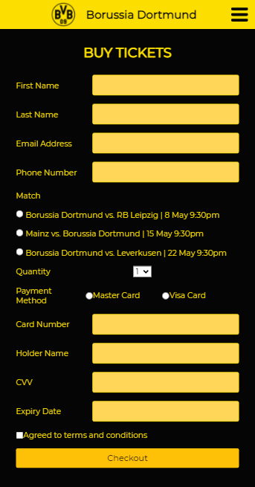

**History**

Then, on the ‘history page’, the user can see the history of the club on this page. It includes different years on this page. It has a function similar to that that we use on the navigation bar where the selected page is highlighted. We think it would gain more interest on our club as they can through this page to know more history of our club. It may make people feel more interested in our club. Such as the establishment of the club or some major incidents or accidents that different years happened.

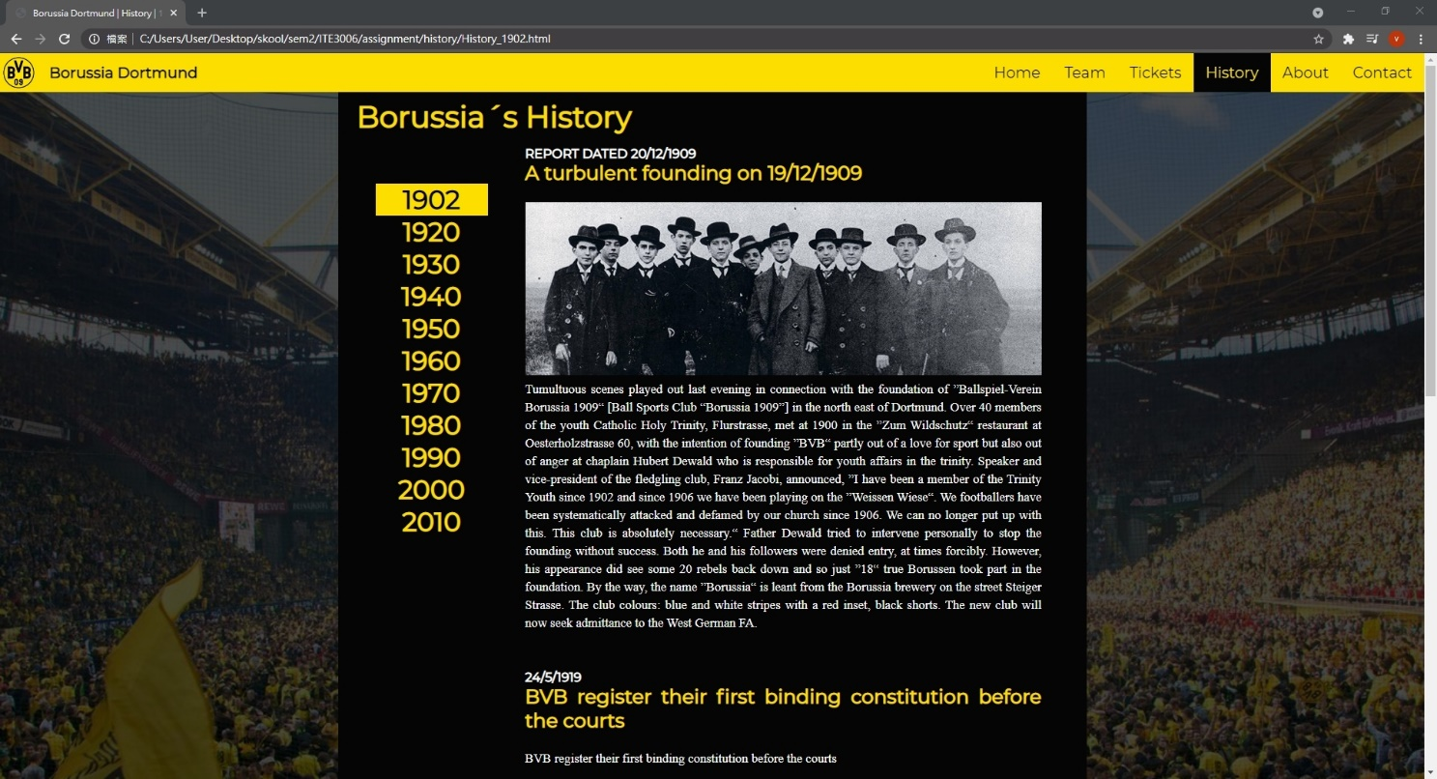

Hover effect:

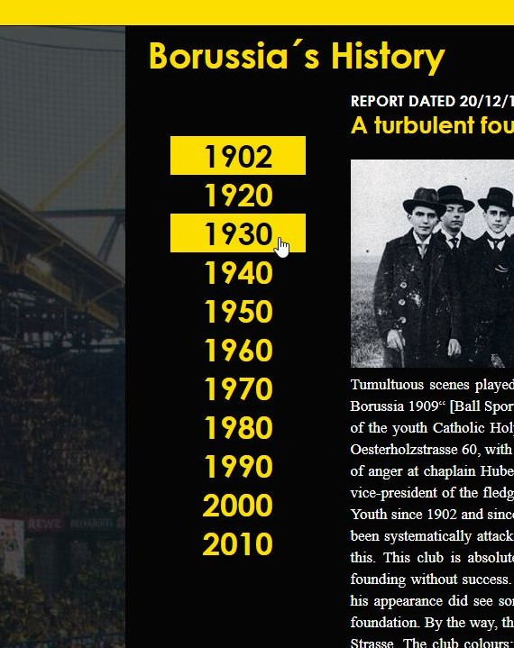

Responsive Layout:

The left navigation bar will be shifted to the top of the page when the widow gets narrow.

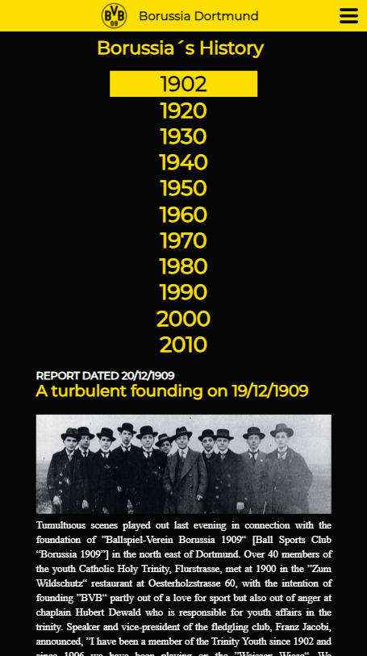

**About**

On the ‘About page, the user would see more introduction about the club. Such as the Intensity of the club, Authenticity, Cohesion, Football experience. It makes the user have more confidence to join our club. Moreover, it also makes users know more information about BVB. It also can let the user know what aim that club wants to do. We think it would attract more people to join us.

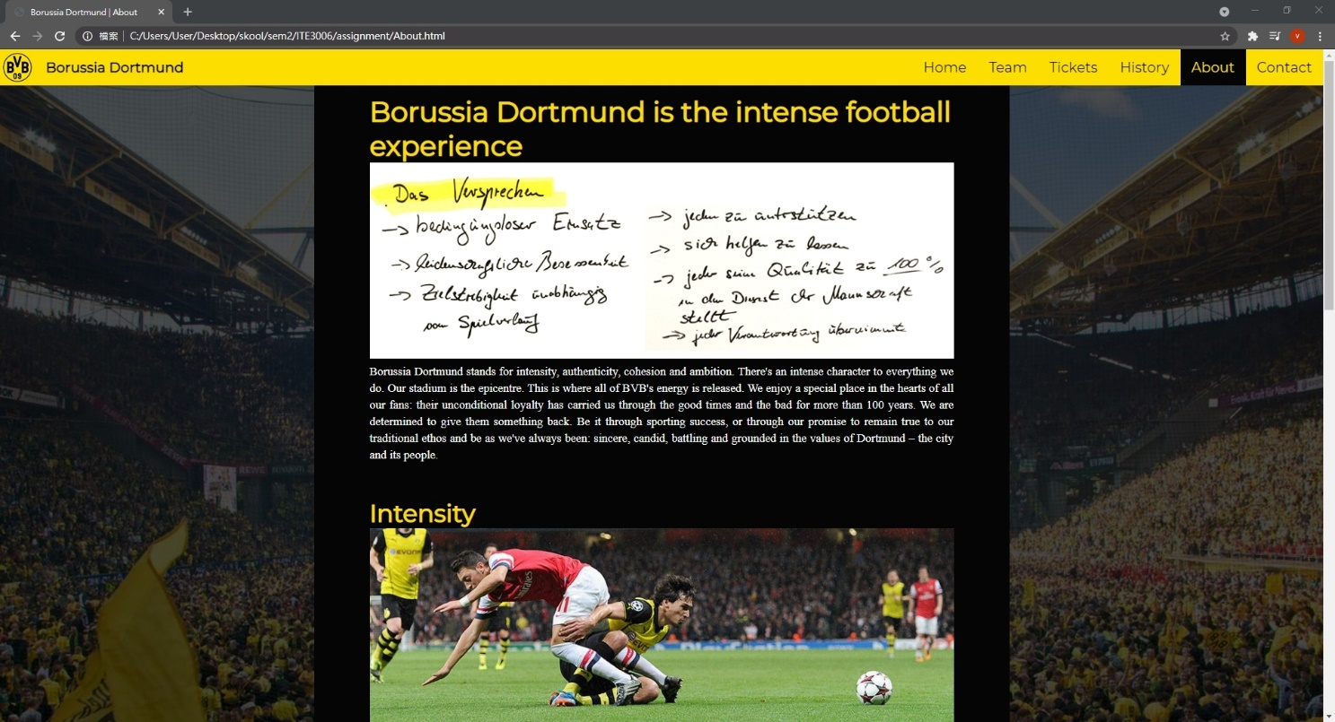

Responsive layout:

Word wrap and image re-size when windows get narrow.

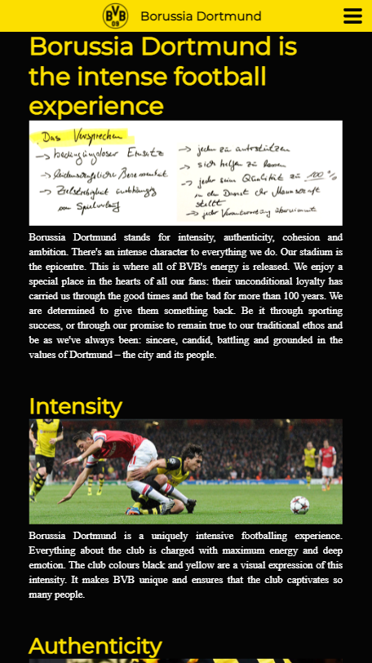

**Contact**

We also have a page for users to contact us (it includes different department information), it includes the location of the club office, phone number, office open time, ticket hotline …… When club members have some problem want to find us. This page will give different ways to help them to find us. It also has a ticket office’s opening hours to show the user. They can know when the offices will open and buy the ticket.

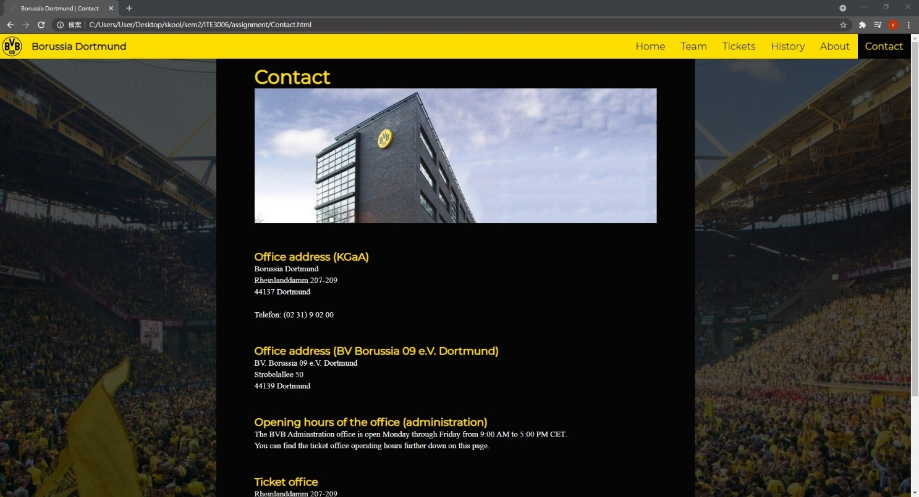

Responsive layout:

Photo of the office will be hidden when window gets narrow

